NAME : WIJAYAWARDHANA W.A.H.A.

REGISTRATION NO. : 2019/E/166

SEMESTER : SEMESTER 04

DATE ASSIGNED : 10 MARCH 2022

LINEAR ABSTRACT DATA TYPES – LAB 03

EC 4070

DATA STRUCTURES AND ALGORITHMS

01.

a).

**Code:-**

public class StackOperation {

int arraySize; // Define arraySize.

int[] stackElementArray = new int[arraySize]; // Define array.

int topValue;

int newElement;

boolean stackEmpty;

boolean stackFull;

public void StackOperation() // Default constructor.

{

arraySize = 0;

topValue = -1;

}

// StackOperation method for setting values.

public void StackOperation(int arraySize , int[] stackElementArray,int topValue)

{

this.arraySize = arraySize;

this.stackElementArray = stackElementArray;

this.topValue = topValue;

stackEmpty = false;

stackFull = false;

}

// isEmpty method for checking the elements are empty or not.

public void isEmpty()

{

if(topValue == -1)

{

stackEmpty = true;

}

else

{

stackEmpty = false;

}

}

// isFull method for checking the elements are full or not.

public void isFull()

{

if(topValue == stackElementArray.length)

{

stackFull = true;

}

else

{

stackFull = false;

}

}

// peek method for output peek value of stack.

public void peek()

{

isEmpty();

if(stackEmpty == true)

{

System.out.println("Stack is empty.");

}

else

{

System.out.println(stackElementArray[topValue-1] + " peek of the stack.");

}

}

// push method for adding new element at end.

public void push(int newElement)

{

this.newElement = newElement;

isFull();

if(stackFull == true)

{

System.out.println("Can not push values stack is fill.");

}

else

{

stackElementArray[topValue] = newElement;

topValue++;

System.out.println(newElement + " push to stack.");

}

}

// pop method for pop the element.

public void pop()

{

if(stackEmpty == true)

{

System.out.println("Stack is empty can not pop values.");

}

else

{

stackElementArray[topValue-1] = 0;

topValue--;

System.out.println("Pop the element from stack.");

}

}

// PrintElement method for print stack.

public void printElement()

{

System.out.print("Elements present in stack : ");

for(int i = topValue-1; i>=0; i--)

{

System.out.print(stackElementArray[i]+ " ");

}

System.out.println();

}

public static void main(String[] args) {

StackOperation newObject = new StackOperation();

int arraySize = 4;

int[] elementArray = new int[]{34, 78, 89, 0};

newObject.StackOperation(arraySize, elementArray, 3);

newObject.peek();

newObject.push(45);

newObject.peek();

newObject.printElement();

newObject.push(66);

newObject.peek();

newObject.pop();

newObject.printElement();

}

}

Outputs:-

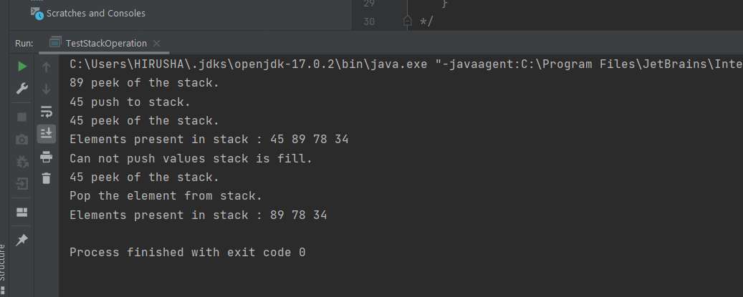

b). 1.

**Code:-**

import java.util.Scanner; // Import scanner library.

public class ReverseWord {

String word; // Define word.

Scanner scanner = new Scanner(System.in); // Create object of scanner.

public void ReverseWord() // Default constructor.

{

word = "WORD";

}

public void ReverseWord(String word) // Default constructor for setting values.

{

this.word = word;

setCharactersArray(word);

}

// setWord method to set a word.

public void setWord()

{

System.out.print("Enter the word : ");

word = scanner.nextLine();

setCharactersArray(word);

}

// setCharactersArray method to take characters to array.

public void setCharactersArray(String word)

{

char[] characters = new char[word.length()];

for(int i =0; i<word.length(); i++)

{

characters[i] = word.charAt(i);

}

printWord(characters);

}

// printWord method to reverse the word.

public void printWord(char[] characters)

{

for(int j = characters.length-1; j>=0; j--)

{

System.out.print(characters[j]);

}

}

public static void main(String[] args) {

ReverseWord newObject = new ReverseWord(); // Crate an object of ReverseWord class.

newObject.setWord(); // Calling setWord method.

}

}

**Output:-**

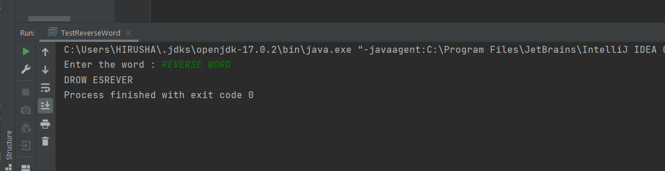

2.

**Code:-**

import java.util.Scanner; // Import scanner library.

import java.util.ArrayList; // Import ArrayList library.

public class DelimitersMatching {

String delimiter; // Define delimiter.

Scanner scanner = new Scanner(System.in); // Create object of scanner.

public void DelimitersMatching() // Default constructor.

{

delimiter = " ";

}

public void setDelimiter() // setDelimiter method for setting elements.

{

System.out.print("Enter : "); // Take the input from user.

delimiter = scanner.nextLine();

}

// setCharacters method for passing to array.

public void setCharacters()

{

int delimiterLength = delimiter.length();

ArrayList<Character> myList = new ArrayList<Character>();

char characters = '+'; // Default char value.

int index = -1;

for(int i =0; i<delimiter.length();i++)

{

characters = delimiter.charAt(i);

if((characters == '{')||(characters == '[')||(characters == '(')) // Check the required character available or not.

{

index++;

myList.add(index,characters);

}

else if((characters == '}')||(characters == ']')||(characters == ')')) // Check with the elements at the last of list.

{

if(characters == '}')

characters = '{';

else if(characters == ')')

characters = '(';

else

characters = '[';

if(myList.get(index) != characters) // If not equal this will print.

{

System.out.println("Error "+myList.get(index) +" "+characters + " on delimiter.");

return;

}

else

{

index--;

}

}

}

System.out.println("Delimiter matching properly."); // If delimiter match properly this will come.

}

public static void main(String[] args) {

DelimitersMatching newObject = new DelimitersMatching(); // Create an object.

newObject.setDelimiter(); // Calling setDelimiter method.

newObject.setCharacters(); // Calling setCharacters method.

}

}

**Output:-**

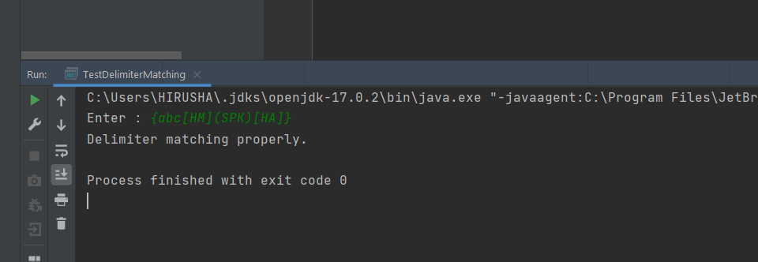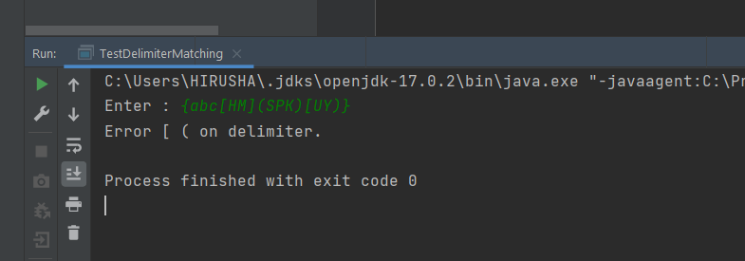

02.

a).

**Code:-**

import java.util.Scanner; // Import scanner library.

public class QueuesOperation {

int queuesFront; // Define queuesFront.

int queuesRear; // Define queuesRear.

int arraySize; // Define arraySize.

int[] queuesElement = new int[arraySize];

Scanner scanner = new Scanner(System.in); // Create an object of scanner.

public void QueuesOperation() { // Default constructor.

queuesRear = -1;

queuesFront = -1;

}

// Default constructor to set element

public void QueuesOperation(int[] queuesElement, int arraySize, int rearValue) {

this.queuesElement = queuesElement;

this.arraySize = arraySize;

queuesRear = rearValue;

queuesFront = 0;

}

// setQueues method for setting values and elements.

public void setQueues() {

System.out.println("Enter size : ");

arraySize = scanner.nextInt(); // Take queue size from user.

boolean queuesEmpty = isEmpty();

if (queuesEmpty == true) {

System.out.println("Queues is empty.");

}

for (int i = queuesRear; i < arraySize; i++) {

System.out.print("Enter element : ");

queuesElement[i] = scanner.nextInt();

}

System.out.println("Queues is full.");

}

// isEmpty method for checking queue empty or not.

public boolean isEmpty() {

if (queuesRear == -1) {

return true;

} else {

return false;

}

}

// peek method for get peek value.

public void peek() {

boolean queuesEmpty = isEmpty();

if (queuesEmpty == true) {

System.out.println("Queues is empty.");

} else {

System.out.println("Peek value of queues : " + queuesElement[queuesFront]);

}

}

// isFull method for checking queue full or not.

public boolean isFull() {

if (queuesRear == queuesElement.length - 1) {

return true;

} else {

return false;

}

}

// enqueue method for adding new element.

public void enqueue(int newElement) {

boolean queuesFull = isFull();

if (queuesFull == true) {

System.out.println("Queues is full.");

} else {

queuesElement[queuesRear - 1] = newElement;

queuesRear++;

}

}

// dequeue method for give front element.

public void dequeue() {

boolean queuesEmpty = isEmpty();

if (queuesEmpty == true) {

System.out.println("Queues is empty.");

} else {

System.out.println("Dequeue of queue : " + queuesElement[queuesFront]);

queuesFront++;

}

}

public static void main(String[] args) {

QueuesOperation queuesObject = new QueuesOperation(); // Crate an object of QueuesOperation class.

int[] queuesArray = new int[10]; // Define an array for queue values.

queuesArray[0] = 12; // Assign values.

queuesArray[1] = 89; // Assign values.

queuesArray[2] = 55; // Assign values.

queuesArray[3] = 69; // Assign values.

queuesArray[4] = 33; // Assign values.

queuesArray[5] = 84; // Assign values.

queuesObject.QueuesOperation(queuesArray, 10, 5); // Calling QueuesOperation method.

queuesObject.peek(); // Calling peek method.

queuesObject.enqueue(55); // Calling enqueue method.

queuesObject.peek(); // Calling peek method.

queuesObject.dequeue(); // Calling dequeue method.

queuesObject.peek(); // Calling peek method.

}

}

**Output:-**

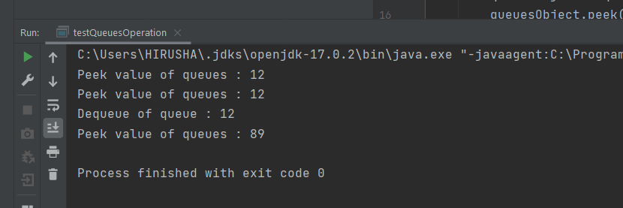

b)

**Code:-**

import java.util.ArrayList; // Import ArrayList library.

public class PriorityQueue {

int queueSize; // Define queue size.

ArrayList<Integer> queueArrayList = new ArrayList<Integer>(queueSize); // Define queueArrayList.

// setQueueArrayList method.

public void setQueueArrayList(ArrayList<Integer> queueArrayList , int queueSize)

{

this.queueSize = queueSize; // Assign queueSize when method calling.

this.queueArrayList = queueArrayList; // Assign queueArrayList when method calling.

}

// arrangeQueue method for prepare the order of queue.

public void arrangeQueue()

{

for(int i = 0; i<queueSize; i++) // Sorting the queue.

{

for(int j = i+1; j <queueSize; j++)

{

if(queueArrayList.get(i) > queueArrayList.get(j)) // Check the elements greater than or less.

{

int temp = queueArrayList.get(i);

queueArrayList.add(i,queueArrayList.get(j));

queueArrayList.remove(i+1);

queueArrayList.add(j,temp);

queueArrayList.remove(j+1);

}

}

}

}

// poll method for removing element.

public void poll(int removingElement)

{

boolean isFound = false; // Define to check element found or not.

for (int i =0; i<queueArrayList.size(); i++)

{

if(queueArrayList.get(i) == removingElement) // Check the element available or not.

{

queueArrayList.remove(i); // Remove the element if it found.

isFound = true;

}

}

if(isFound == false) // If nor found this part will run.

{

System.out.println("Could not found " + removingElement +" element.");

}

}

// add method for adding element to queue.

public void add(int addingElement)

{

for (int k = 0; k <queueArrayList.size(); k++) // Check the suitable place for element.

{

if((addingElement <= queueArrayList.get(k))&&(k ==0))

{

queueArrayList.add(k,addingElement);

}

else if((addingElement>queueArrayList.get(k))&&(k == queueArrayList.size()-1))

{

queueArrayList.add(k+1,addingElement);

}

else if((addingElement>queueArrayList.get(k)) && (addingElement<=queueArrayList.get(k+1)))

{

queueArrayList.add(k+1,addingElement);

}

}

}

// Print method to print link list.

public void printQueue()

{

for (int j =0; j < queueArrayList.size(); j++)

{

System.out.print(queueArrayList.get(j) + " ");

}

System.out.println();

}

public static void main(String[] args) {

PriorityQueue newObject = new PriorityQueue(); // Creating an object of the PriorityQueue class.

ArrayList<Integer> queueArrayList = new ArrayList<Integer>(); // Define the array list.

queueArrayList.add(56); // Adding elements to array list.

queueArrayList.add(89); // Adding elements to array list.

queueArrayList.add(12); // Adding elements to array list.

queueArrayList.add(77); // Adding elements to array list.

queueArrayList.add(83); // Adding elements to array list.

queueArrayList.add(90); // Adding elements to array list.

queueArrayList.add(4); // Adding elements to array list.

queueArrayList.add(69); // Adding elements to array list.

queueArrayList.add(43); // Adding elements to array list.

newObject.setQueueArrayList(queueArrayList,queueArrayList.size()); // Calling setQueueArrayList method for setting element.

newObject.printQueue(); // Calling printQueue method.

System.out.println("After arrange the queue.");

newObject.arrangeQueue(); // Calling arrangeQueue method.

newObject.printQueue(); // Calling printQueue method.

System.out.println("Adding element to queue");

newObject.add(75); // Calling add method.

newObject.printQueue(); // Calling printQueue method.

System.out.println("Remove 44 element from queue");

newObject.poll(44); // Calling poll method for remove item.

newObject.printQueue(); // Calling printQueue method.

System.out.println("Remove 56 element from queue");

newObject.poll(56); // Calling poll method for remove item.

newObject.printQueue(); // Calling printQueue method.

}

}

**Output:-**

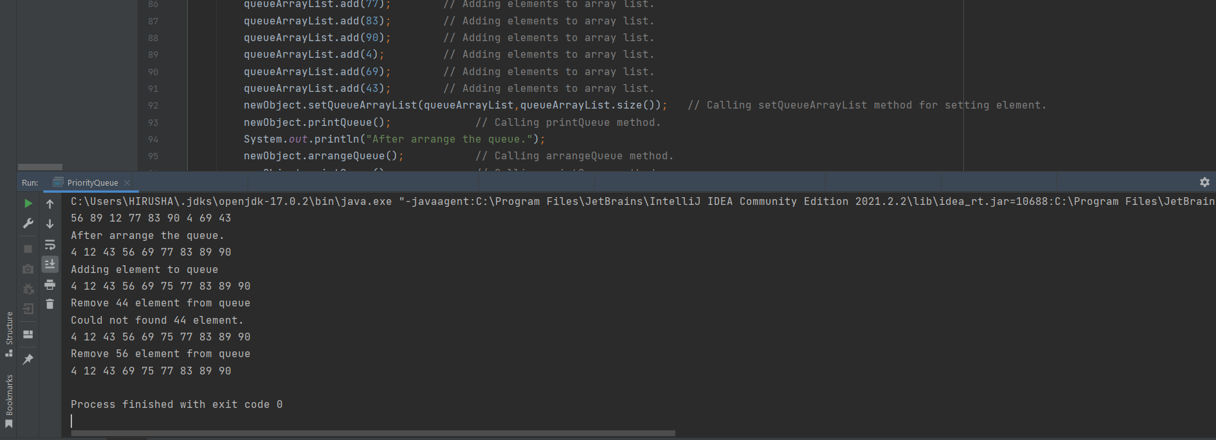

03.

**Code:-**

import java.util.ArrayList; // Import ArrayList library.

public class LinkList {

ArrayList<Integer> linkListArrayList = new ArrayList<Integer>(); // Define an array list.

int linkListIndex; // Define array size.

public void LinkList() // Default constructor.

{

linkListIndex = 0;

}

// Setting link list.

public void setLinkList(ArrayList<Integer> linkListArrayList , int linkListIndex)

{

this.linkListArrayList = linkListArrayList; // Assigning the link list to array list.

this.linkListIndex = linkListIndex; // Assigning link list size.

}

// Append new node method for adding mew element at end.

public void appendNewNode(int newElement)

{

linkListArrayList.add(linkListIndex+1,newElement); // Adding new element.

linkListIndex++;

}

// Prepend new node method for adding mew element at front.

public void prependNewNode(int newElement)

{

linkListArrayList.add((0),newElement);

}

// Delete the node at the front.

public void deleteAtStart()

{

linkListArrayList.remove(0);

}

// Delete an element at specific place.

public void deleteAtSpecificPosition(int indexForDelete)

{

linkListArrayList.remove(indexForDelete);

}

// Print method to print link list.

public void printArrayList()

{

for (int j =0; j < linkListArrayList.size(); j++)

{

System.out.print(linkListArrayList.get(j) + " ");

}

System.out.println();

}

public static void main(String[] args) {

ArrayList<Integer> arrayList = new ArrayList<>(); // Define the array list.

LinkList newObject = new LinkList(); // Creating an object of the LinkList class.

arrayList.add(0,55); // Adding elements to array list.

arrayList.add(1,67); // Adding elements to array list.

arrayList.add(2,90); // Adding elements to array list.

arrayList.add(3,19); // Adding elements to array list.

newObject.setLinkList(arrayList , arrayList.size()-1); // Calling the setLinkList method.

System.out.println("Link list at start.");

newObject.printArrayList(); // Calling printArrayList method.

newObject.appendNewNode(12); // Calling appendNewNode method.

System.out.println("After adding new element at end.");

newObject.printArrayList(); // Calling printArrayList method.

newObject.prependNewNode(99); // Calling prependNewNode method.

System.out.println("After adding new element at front.");

newObject.printArrayList(); // Calling printArrayList method.

newObject.deleteAtStart(); // Calling deleteAtStart method.

System.out.println("Delete element at front.");

newObject.printArrayList(); // Calling printArrayList method.

newObject.deleteAtSpecificPosition(3); // Calling deleteAtSpecificPosition method.

System.out.println("Delete element at 3 index.");

newObject.printArrayList(); // Calling printArrayList method.

}

}

**Output:-**

